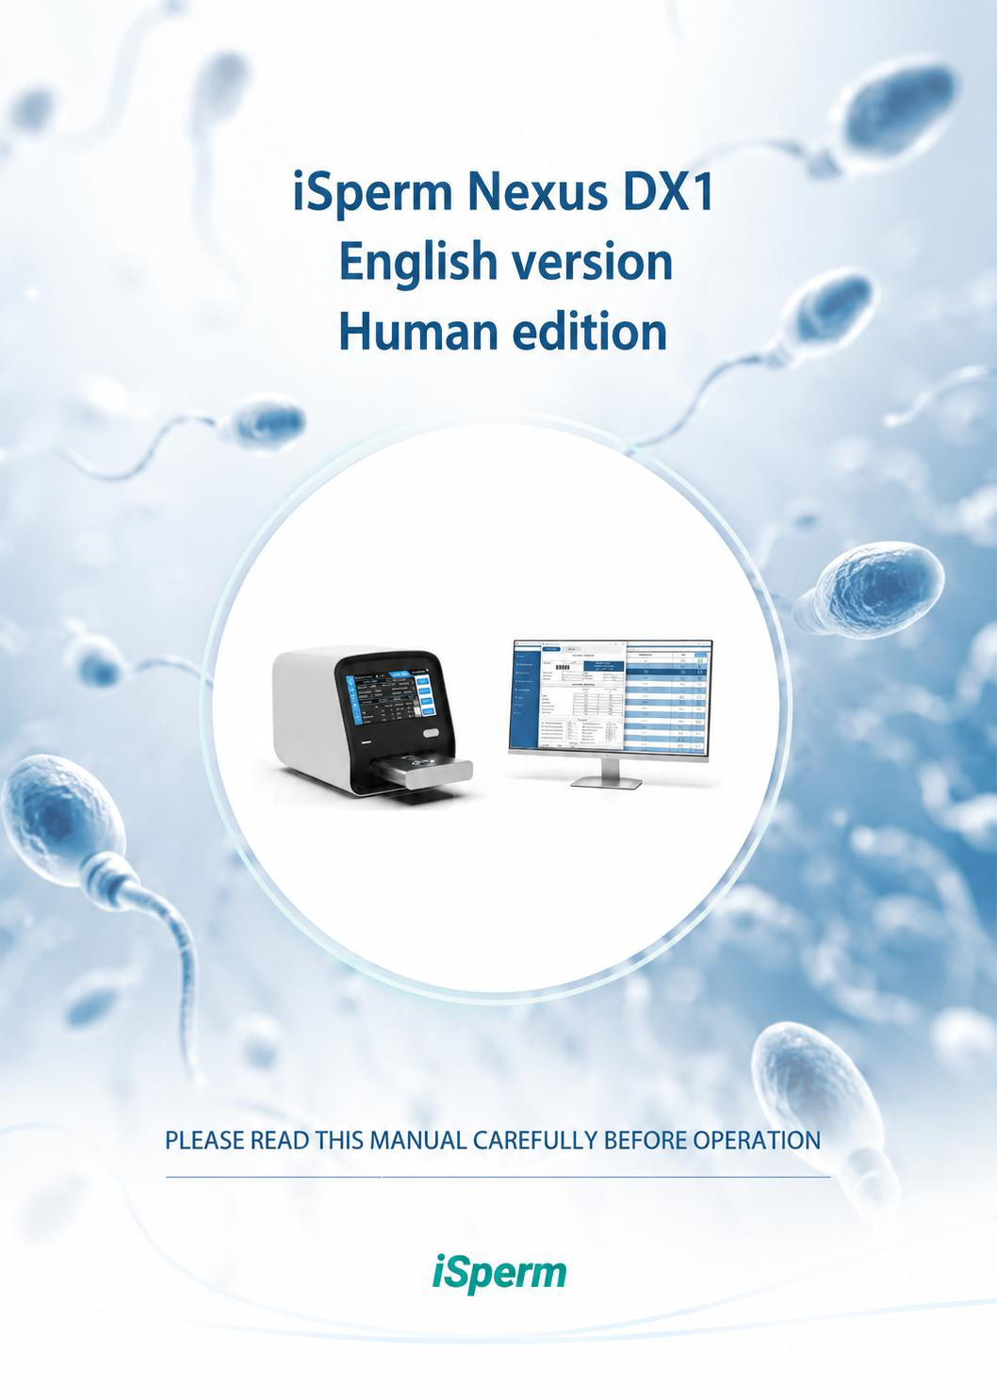

iSperm Nexus DX1 User’s Guide - English Version – HUMAN edition Version: 1
Language: English
Release date: July 2026
© 2026 iSperm Medical


 | iSperm Medical  www.isperm.com - market@isperm.com

Table of contents
1  1.1  1.2  1.3  1.4  2  2.1  2.2  2.3  3  3.1  3.2  3.3  4  4.1  4.2  4.2.1 4.2.2 4.2.3 4.2.4 | Introduction ............................................................................................................ 16 Product information ................................................................................................ 16 Product structure and components ........................................................................ 16 Product applicability ............................................................................................... 17 Equipment technique parameter ............................................................................ 17  Equipment description ............................................................................................ 18 Front view ............................................................................................................... 18 Back view ................................................................................................................ 20 Other components .................................................................................................. 21  Equipment installation ............................................................................................ 22 Equipment opening and sealing .............................................................................. 22 Select proper position ............................................................................................. 25 Power source requirement ..................................................................................... 25  First use ................................................................................................................... 26 Main screen............................................................................................................. 26 Settings ................................................................................................................... 27 General .................................................................................................................... 27 Analyze .................................................................................................................... 32 Reports .................................................................................................................... 40 Users ....................................................................................................................... 47



Intended use
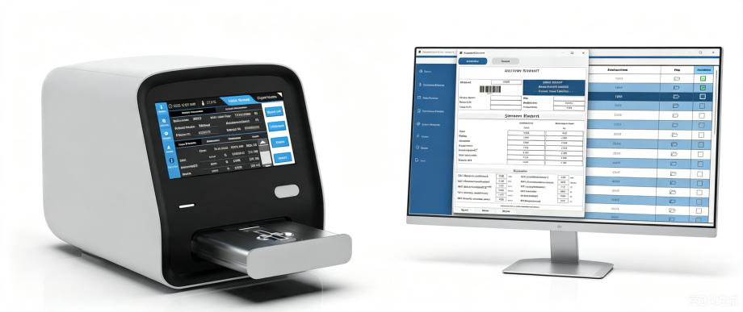
The device is intended for the automated acquisition and processing of microscopic images of in vitro human semen samples.
The device generates structured, image-derived data representing observable characteristics of the samples, to support laboratory-related activities such as method standardization, workflow consistency control, and internal reference purposes.
The device does not provide medical interpretation, is not intended to establish or exclude any clinical condition, and shall not be used as an independent basis for diagnostic or therapeutic decision-making.
The outputs generated by the device are non-decisional and auxiliary in nature, and are intended to be used by qualified professionals in conjunction with other laboratory information and relevant contextual data.
Intended use | 8

Intended use | 9

How to use this manual
Thank you for choosing the iSperm Nexus DX1 semen analyzer.
For safe and reliable operation, read this manual carefully and become familiar with the instrument functions before routine laboratory use.
This manual provides operating guidance for the Nexus DX1 semen analyzer, including installation, routine operation, settings, report management, quality control, cleaning, and maintenance.
Keep the original packing materials for future storage, transport, or service return.
If you have any question or instrument problem, contact your distributor or authorized service provider.
Warning:
 | Warnings, cautions, and notes must be followed to support safe operation, stable instrument performance, and reliable test records.
How to use this manual |  | 10

How to use this manual | 11

Symbols on the equipment
 This means that the labelled item could lead to personal injury and/or damage to
the analyser. The symbol is labelled beside the power outlet and some external
interface.
 The symbols for “SERIAL NUMBER”, The serial number shall be after or below the
symbol, adjacent to it.
 The symbol indicates the manufacturer and its address, after which are shown its
name and address.
 The symbol indicates the date of manufacture, after which are shown its
manufacture date.
 The symbol means that the environment of equipment must be damp proof
during transport, and equipment must be kept in a dry environment.
 This means that equipment should handle with care during transportation, so as
not to damage it.
 The symbol means the equipment packaged should not be upended at any time.
 | This symbol indicates that when the end-user wishes to discard this product, it must be sent to separate collection facilities for recovery and recycling. By separating this product from other household-type waste, the volume of waste
sent to incinerators or land-fills will be reduced and natural resources will thus
be conserved.

Symbols on the equipment | 12

Symbols on the equipment | 13

Warning | and | safety
indications
This equipment is only used for in vitro diagnosis, please carefully read the following
warnings before the usage, and strictly obeys them.
Read all safety instructions before using this equipment.

Cut off the power source at once if there are abnormal smells or smokes and pull out the

power plug from the outlet. At that moment, you must immediately propose test

applications to the distributors and the agents of our company. If it is continuously used

under this condition, it may cause fire, electric shock or personnel casualty.

Neither water and reagent nor metal pieces of staple and pin should be dropped into the

equipment; otherwise it would lead to short circuit or smoke and fire. If there is

something abnormal, cut off the power source at once, and pull out the power plug from

the outlet. At that moment, you must immediately propose test applications to the

distributors and the agents of our company.

Operators don’t touch the electric circuit inside the equipment, especially wet hands,

which may be easier to get electric shock.

Rubber gloves must be put on while maintaining and checking the equipment, and

prescriptive tools and spare parts should be used. After finishing the operation, please

use disinfecting liquid soap to wash hands.

The used tubes and other equipment should be properly disposed as the medical wastes

or infective wastes. If the person is stained with blood, there is possibility of being

infected by pathogens.
Power voltage, connection and earthing
Be sure not to insert the plug into the electrical outlet of alternating current over 220v.

Otherwise, it may cause fire or electrical shock.
Warning and safety indications | 14

When the equipment is installed, three-core power cable accompanied with the machine

must be used, and ensure it is well earthling. Otherwise, it may cause fire or electrical

shock.

Be sure not to damage the isolation protection peel of power line. Do not pull the power

line with exertion or hang heavy things on it. Otherwise, it may cause broken circuit or

short circuit, thus lead to electrical shock or fire.

Power source must be cut off when connect the peripheral equipment. Otherwise, it may

cause electrical shock or troubles.
Shelf-Life
Once the device is put into operation, there is a shelf life of 6 years. The 6-year device life-
time limit is applicable if the final user chooses NOT to install software updates that may
be developed by the constant evolution of technology and incorporation of new clinical
tests.
Warning and safety indications | 15

1 | Introduction
1.1Product information
Product name: Nexus Dx1

Model: v.1.0

Product property:

Nexus Dx1 is an automate system intended for the automated acquisition and processing

of microscopic images of in vitro human semen samples.:
▪ | Concentration: Calculates the total sperm number of a semen sample and the sperm

▪  ▪  ▪ | concentration (M/mL).  Motility: Calculates the total percentage of motile sperm.  Morphology: Calculates the total percentage of morphology pattern sperm. Round cells pattern: Calculates the concentration of round cells like Non-sperm

particles.

After the analysis, the system sends all the results, videos, images and sessions to the
Laboratory Information System (LIS), where is possible to check the analysis or print
reports.
1.2Product structure and components
Nexus Dx1 is internally composed by:
Optical system

Motorized stage

Warm stage

Digital camera

Computer control system and software
1. Introduction | 16

1.3Product applicability
Nexus Dx1 is intended for the automated acquisition and processing of microscopic images of in vitro human semen samples.
1.4Technical specifications
Light source: LED light

Temperature control: 35 - 40 ºC (37ºC as default)

Interface: RJ45 protocol

Display: Internal displayer 7 inches

Print: External printer

Work environment: 0ºC to 40ºC; relative humidity<85%

Storage environment: -10ºC to 40ºC; relative humidity<85%

Weight: 7kg

Overall dimensions: 283mm(L)207mm(W)x244mm(H)

Power supply: A.C. 110V/240V, 50Hz/60Hz

Power input: 12V 5A
1. Introduction | 17

2 | Equipment description
2.1Front view
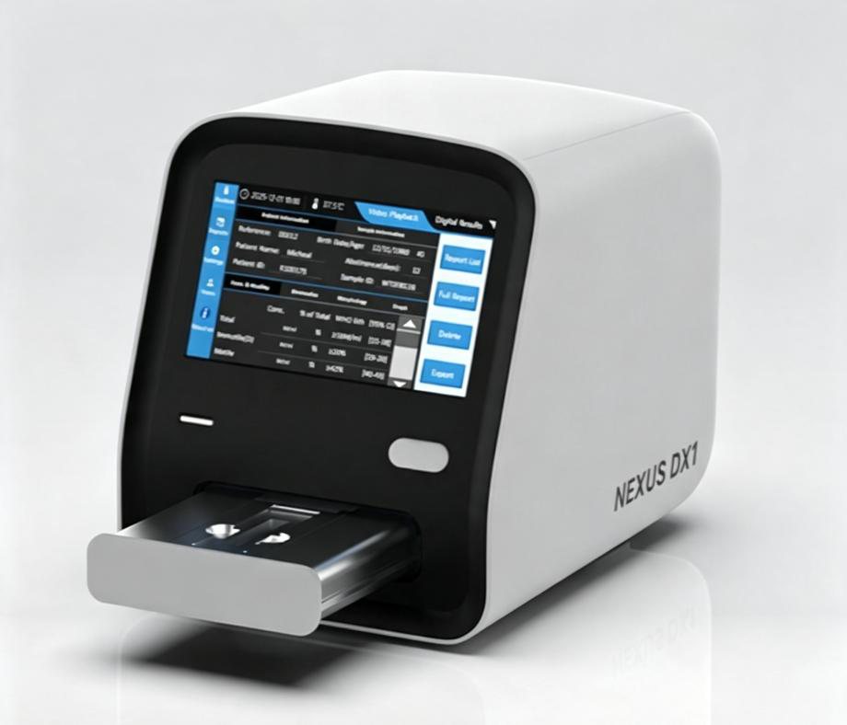
Figure 1. Nexus Dx1 front view

2. Equipment description | 18

1.Indicating lamp (left): Power and function lamp.
▪ | Always on if power switch is on.
  
  Figure 22. lamp: Power switch is on

▪ | Off if power switch on the rear panel is off.
  
  Figure 33. lamp: Power switch is off

▪ | Green: Always on if the system is ok.
  Figure 44. lamp: System is OK

▪ | Red: Be careful. Warning or problem inside the hardware system.
  
  Figure 55. lamp: Hardware problem

▪ | Blue: Be careful. Warning or problem inside the software system.
  
  Figure 66. lamp: Software problem
2.Sleep/Wake-up Button (Right)
Press this button to put the screen into sleep mode. When the screen enters sleep
state manually or automatically, press this button to wake the screen up.
2. Equipment description | 19

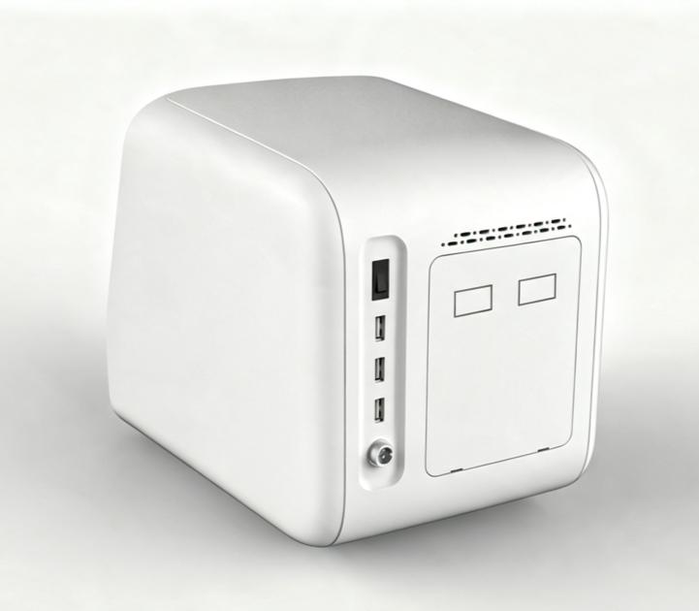
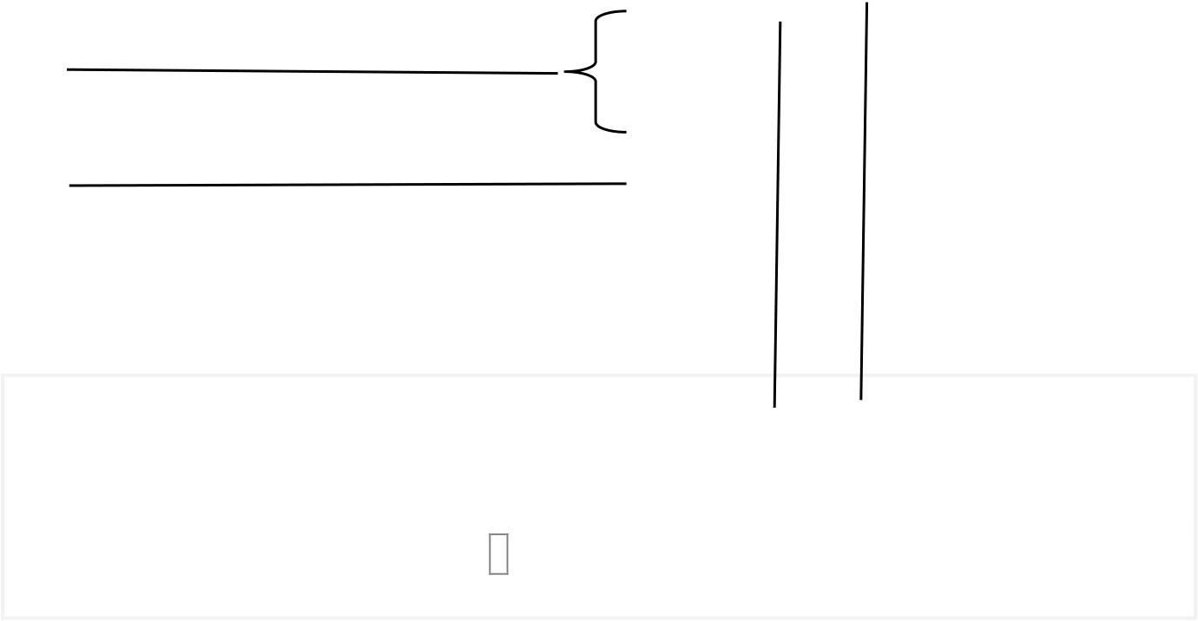
2.2Back view
1
4
5
2 3
Figure 7. Nexus Dx1 back view
1.Power switch

2.PC Monitor connection (Screen Port)

3.PC software connection (Data port)

4.3 USB ports. Connect keyboard, mouse, barcode scanner, USB disk

5.Power cable
2. Equipment description | 20

2.3Other components
Nexus Dx1 also includes the following components:
1.Barcode scanner wired

2.Keyboard + mouse

3.USB flash drive (for APP update, Export Reports), FAT32 Only, Device-Specific

4.Screen port cable (Mirco USB cable)

5.Data port cable (Network RJ45 cable)

6.Power Adapter (Input: 100-240V 50/60Hz 1.4A, Output: +12V 5A 60W)
This system is also compatible with any USB keyboard and mouse which is compatible with PC.
2. Equipment description | 21

3 Equipment
installation
3.1Equipment opening and sealing
1.Open the transportation box.

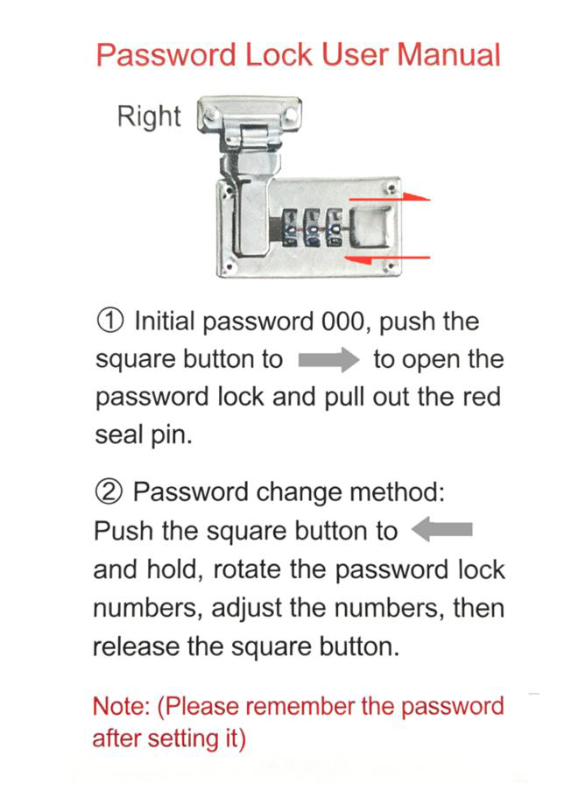
Figure 8. Transportation box lock

2.Take off the packing materials and take the equipment out of the package. Be

careful: Nexus Dx1 is a heavy equipment. Preserve the packing box and materials well

provided that you may need to repack the equipment in the future.

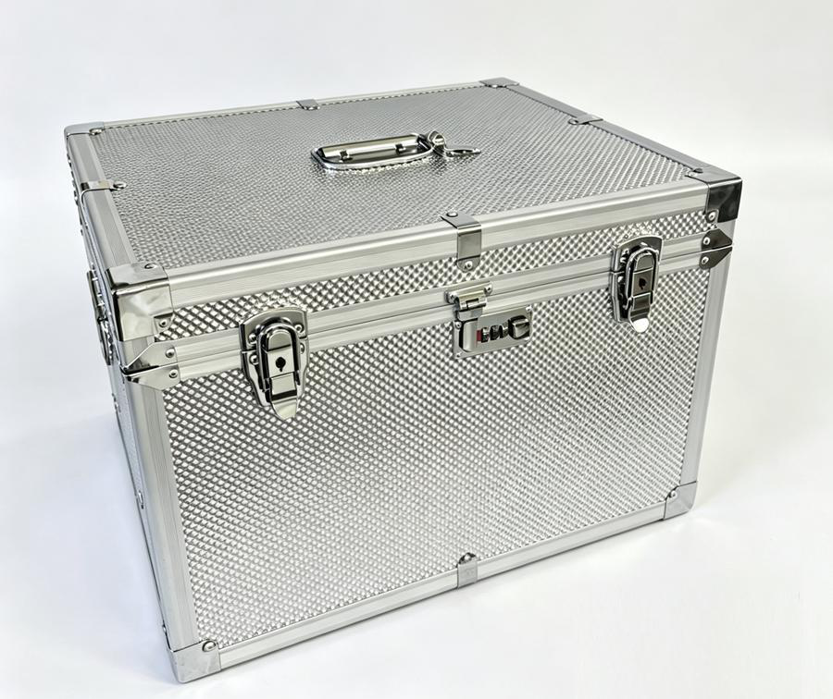
Figure 9. Content of the packing box

included:
▪ | Nexus Dx1 Analyzer
▪ | User’s manual
▪ | Packing list
▪ | Warranty certificate
▪ | Power line and AC adapter
▪ | Keyboard and mouse
▪ | Barcode scanner
▪ | RJ45 adapter USB to Ethernet cable
▪ | Data port cable
▪ | Screen port cable
▪ | USB flash drive (FAT32 formatted)

3.Check the articles inside the package box, and confirm the following stuffs should be

Note: The supplied accessories shall follow the packing list included with the instrument. Contact the distributor if any item is missing, damaged, or inconsistent with the packing list.

3.2Select proper position
Select a clean, dry location without direct sunlight. The workbench should be flat, stable, and large enough for the Nexus DX1, accessories, and routine sample handling. Avoid vibration or shaking of the workbench.
Note: The work environment of equipment is that temperature is between 0ºC-40ºC and relative humidity is below 85%.
To guarantee the normal working of equipment, the following places are forbidden to be put on:
▪  ▪  ▪  ▪  ▪  ▪ | Places with extreme changes of temperature.  Places near a centrifuge or shaking machines.  Particularly hot or cold places.  Places full of dust.  Places nearer to the electromagnetic devices that produce magnetic field. Places with direct sunshine.
3.3Power source requirement
A.C.110V/240V

50Hz/60Hz

60VA

4 | First use
4.1Main screen
1.Switch on the Nexus Dx1.
After starting the system, the main screen (7" Built-in LCD Touch Screen) will appear:
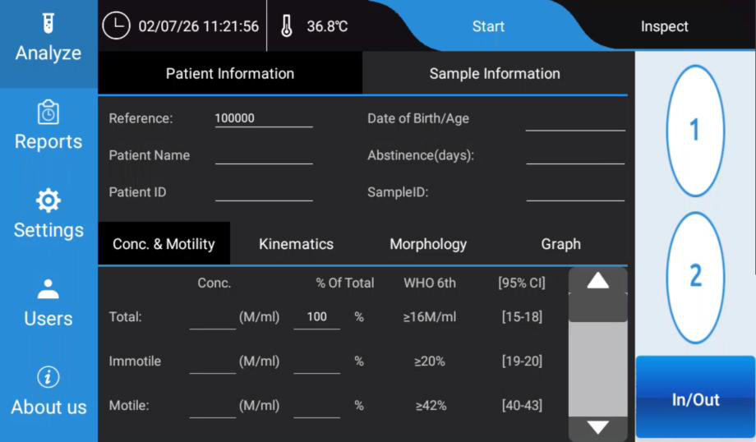
Figure 10. Main screen

Options available:
 Language selector: Change the system’s language.
 Power options: ▪ Shut down: Turn off the system.
▪ Restart: Turn off the system and restart it automatically.

 Settings: Access to the system’s configuration options.
4.2Settings
Click the “Settings” button to enter to the system’s configuration menu. The “Settings” button is available at the main screen as well as the “Analysis” screen.
4.2.1 General
In this section, there is the option of Microscopic Fields, setting to adjust the number of imaging fields per chamber. Available selections are 1, 2, or 3. When you pick a value, the system will analyze that many fields within each sample chamber, then calculate an average value from all captured fields.
Using more fields delivers higher test accuracy, though it will take longer to complete analysis.
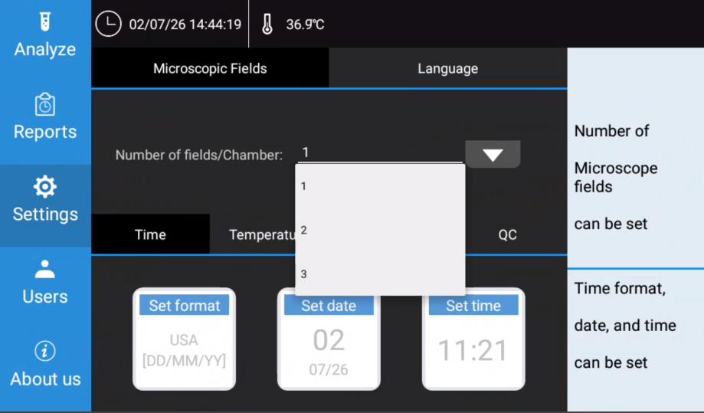
Figure Figure 1032. Settings menu/ Language
1111. Settings menu/ Microscopic Fields
In this section, there is the option of Language selector: Change the system’s language.

A total of twelve different languages are available for selection in the dropdown menu.
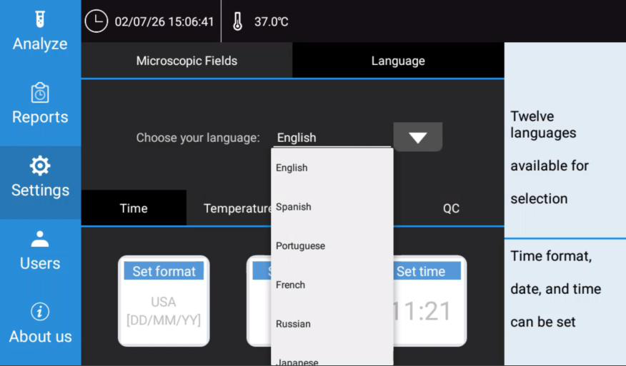
Figure 1212. Settings menu/ Language
In this section, there is the option of Time. Time format, date, and time can be set.
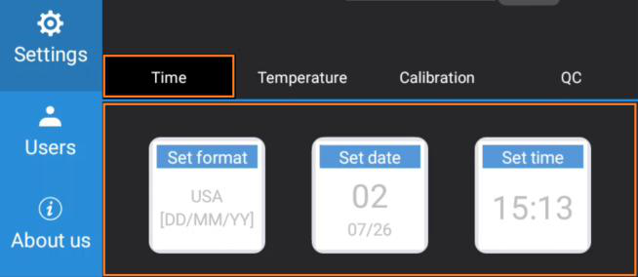
Figure 1313. Settings menu/ Time

In time format section, there are two formats available: USA [MM/DD/YY] and Europe

[DD/MM/YY].

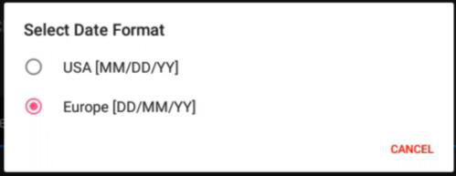
Figure 1414. Settings menu/ Time / format

In date section, you can set the system’s current date.

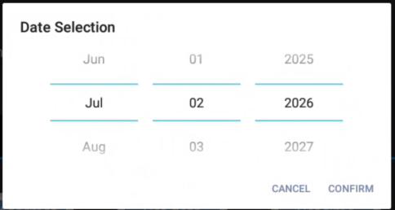
Figure 1515. Settings menu/ Time / date

In time section, you can set the system’s current time.

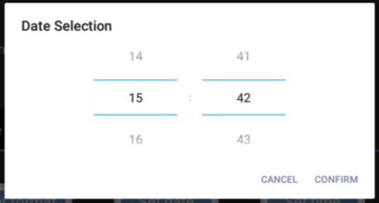
Figure 1616. Settings menu/ Time / time
In Temperature section, the temperature of the platform can be set, the range is 35°C ~ 40°C.
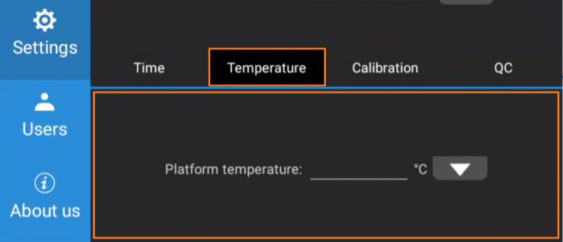
Figure 1717. Settings menu/ Temperature
In Calibration section, the calibration factor of concentration and motility can be set. More information at Calibration guide.

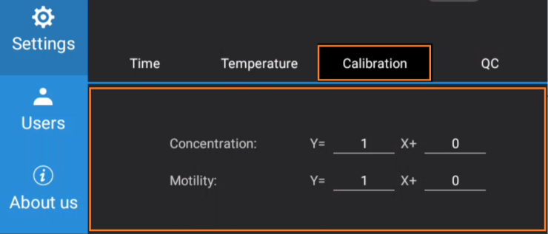
Figure 1818. Settings menu/ Calibration
In QC section, the QC test using Latex beads can be performed. More information at
Calibration guide.
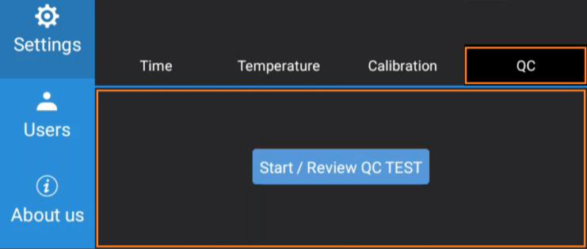
Figure 1919. Settings menu/ QC

4.2.2 Analyze
4.2.2.1Overview
The Analyze function is used to inspect a semen sample image, select the chamber to be
tested, enter optional patient and sample information, and start an automated sperm
quality analysis.
Nexus DX1 is designed for a simplified workflow. The operator may enter patient and
sample information before testing, or leave the information fields blank. If no information
is entered, the system automatically assigns a unique Reference number to the test
record. The analysis result can later be found in the Reports section by using this
reference number.
The analysis result is displayed in four result tabs at the lower part of the screen:
•Conc. & Motility
•Kinematics
•Morphology
•Graph
Note: Nexus DX1 provides image-derived analysis data for laboratory use. Final
clinical interpretation should be made by qualified professionals according to local
laboratory procedures and applicable clinical guidelines.
4.2.2.2Analyze Screen
From the left navigation bar, tap Analyze to enter the analysis function.
The Analyze screen contains the following main areas:
Area Description
Top status bar Displays system time and heating stage temperature.
Start / Inspect tabs Used to inspect the sample and start a test.
Patient Used to enter or confirm patient-related information.
Information
Sample Used to enter or confirm sample-related information.
Information
Chamber selection Used to select chamber 1 or 2.
Result tabs Displays Conc. & Motility, Kinematics, Morphology, and Graph
results.

Figure 20. Main screen/ Analyze
4.2.2.3Inspect the Sample
Before starting a test, the operator should inspect the semen sample image.
1.Tap Analyze on the left navigation bar.
2.Tap Inspect on the upper-right area of the screen.
3.Select chamber 1 or chamber 2.
4.Observe the microscopic image of the semen sample.
5.Confirm that the selected chamber contains a suitable sample image for analysis.
Use the chamber that contains the sample image you want to analyze. The test will be
performed on the microscopic image from the chamber selected during the Inspect step.
If the sample image is not suitable, prepare or load the sample again according to the
laboratory procedure before starting the test.
4.2.2.4Enter Patient Information
After inspection, tap Start to enter or confirm patient and sample information.

In the Patient Information section, the operator may enter:
•Reference
•Patient Name
•Patient ID
•Date of Birth / Age
•Abstinence (days)
•Sample ID
The Reference field is automatically generated by the system. The operator may use this
reference number to locate the result in the Reports section after the test.
Patient information is optional. If the fields are left blank, the system can still start the
analysis and save the result with the automatically assigned reference number.
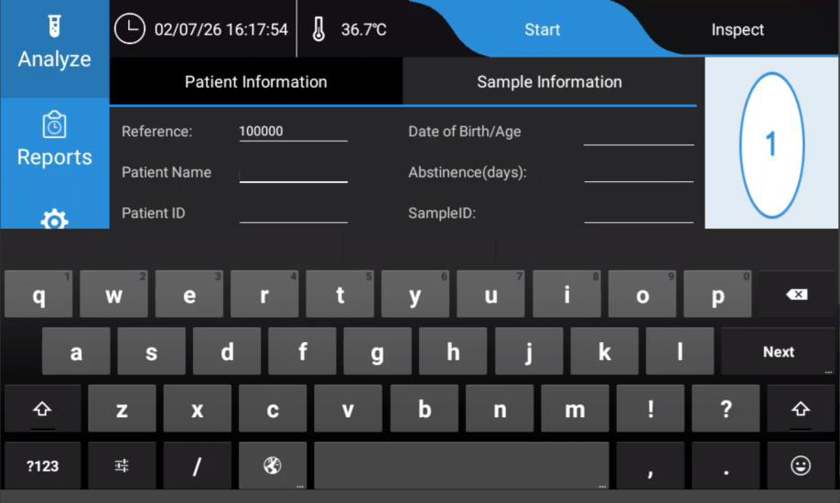
Figure 21. Patient Information

4.2.2.5Enter Sample Information
In the Sample Information section, the operator may enter:
•Liquefaction time
•Liquefaction treatment
•Visual appearance
•Viscosity
•PH
•Ejaculate Volume
•Total Sperm Number (system calculate)
Sample information is optional. However, entering complete information is recommended
when the result will be reviewed, printed, exported, or linked to external laboratory
records.
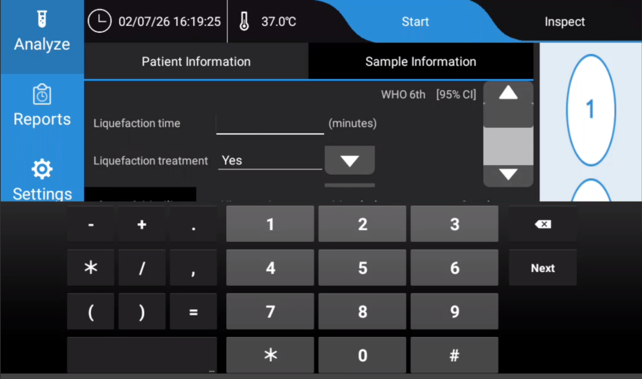
Figure 22. Sample Information

4.2.2.6Start the Test
After confirming the selected chamber and entering any required information: 1.Tap Start.
2.A confirmation message appears:
“Is all information input completed? Start the test?”3.Tap YES to start the analysis.
4.Tap NO to return to the information screen and check or edit the information.
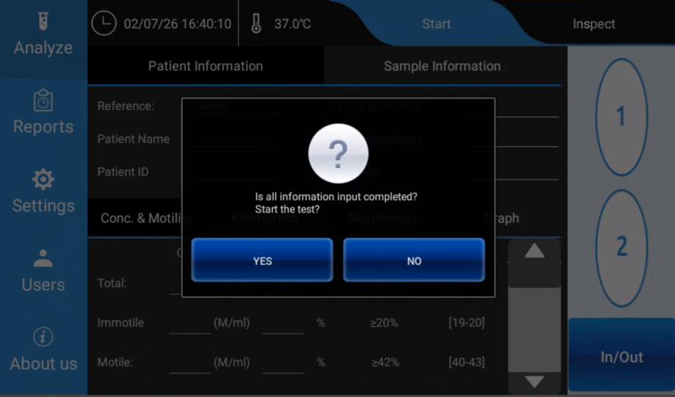
Figure 23. Start test confirmation dialog
When YES is selected, Nexus DX1 starts automated analysis of the semen microscopic image in the selected chamber.
Do not remove the sample, switch chambers, or interrupt the instrument during the test unless instructed by the system.

4.2.2.7View Analysis Results
After the test is completed, the result is shown in the lower part of the Analyze screen.
The operator can switch between the four result tabs.
7.1 Conc. & Motility
The Conc. & Motility tab displays concentration and motility-related results.
Typical displayed information includes:
•Total (sperm concentration)
•Immotile (sperm)
•Motile (sperm)
•PR (Progressive)
•Rapid-PR (Rapid progressive)
•NP (Non Progressive)
•Round cells (Round cells like Non-sperm particles)
The values shown in this tab are used to review the overall concentration and motility
profile of the sample.
7.2 Kinematics
The Kinematics tab displays sperm movement parameters calculated from the analyzed
image sequence.
Depending on system configuration, kinematic parameters may include:
•DCL (Distance along the curvilinear path)
•DSL (Distance along the straight-line path)
•DAP (Distance along the average path)
•VCL (velocity along the curvilinear path)
•VSL (velocity along the straight-line path)
•VAP (velocity along the average path)
•ALH (the amplitude of the lateral displacement of the head)
•MAD (mean angular displacement (degrees))
•BCF (beat-cross frequency (Hz))
•LIN (linearity of the curvilinear path)
•STR (straightness: linearity of the average path (straight-line velocity / average
path velocity))
•WOB (wobble: a measure of oscillation of the curvilinear path about the average
path (average path velocity / curvilinear velocity))
These parameters help describe sperm movement pattern and trajectory characteristics.

7.3 Morphology
The Morphology tab displays morphology-related analysis results.
Depending on the enabled analysis configuration, the system may provide information
related to:
•Normal (sperm)
•Abnormal (sperm)
•Head defects (Head feature distribution)
•Midpiece defects (Midpiece feature distribution)
•Tail defects (Tail feature distribution)
•CR (Cytoplasmic residue)
•TZI (Teratozoospermia index)
•SDI (sperm deformity index)
Morphology results should be reviewed according to the laboratory’s validated
procedures.
7.4 Graph
The Graph tab displays graphical analysis information. This view helps the operator review
the sample result visually and include motility chart, morphology chart.
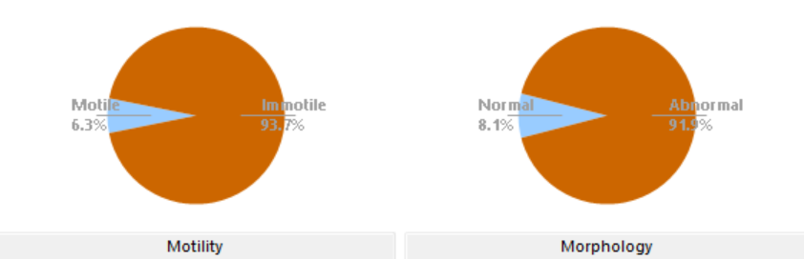
Figure 24. Result/Graph

4.2.2.8Retrieve the Result from Reports
Each completed test is saved by the system. If patient or sample information was not
entered, use the automatically generated Reference number to identify the record.
To retrieve a result:
1.Tap Reports on the left navigation bar.
2.Locate the test record by reference number, patient information, sample
information, or test time.
3.Open the record to view, print, export, or review the report according to the
available report functions.
4.2.2.9Recommended Operating Notes
•Inspect the chamber before starting the test.
•Confirm that the correct chamber, 1 or 2, is selected.
•Enter patient and sample information when traceability is required.
•If information is not entered, record or note the automatically generated
reference number.
•Do not disturb the instrument during analysis.
•Review all result tabs before saving, printing, or exporting the report.
•Follow the laboratory’s sample preparation and quality control procedures.
4.2.2.10 Troubleshooting
Situation | Possible Cause | Recommended Action
The operator cannot find the result after testing. | Patient or sample  information was not entered. | Search in Reports using the  automatically generated reference number or test time.
The wrong chamber was analyzed. | Chamber selection was not confirmed during Inspect. | Repeat the analysis with the correct chamber selected.
The confirmation  dialog appears before the operator is ready. | Start was tapped before information entry was completed. | Tap NO, complete or confirm the information, then tap Start again.
Result fields are incomplete or  unexpected. | Sample image, chamber loading, or analysis  conditions may not be | Inspect the sample image again, prepare a new chamber if needed, and repeat the test according to

Situation | Possible Cause | Recommended Action
 | suitable. | laboratory procedure.

4.2.3 | Reports
The Reports function is used to review, open, delete, and export completed Nexus DX1 test results. This module is always
included in Nexus DX1 .
The Reports function is used to review, open, delete, and export completed test results.
Each completed analysis is saved as a report record. The operator can review the digital
result data, open the full report, play back the analysis video, delete selected records, or
export reports to the USB flash disk supplied with the instrument.
The Reports screen includes two main viewing modes:
•Digital Results: Displays the report list and numerical result details.
•Video Playback: Displays the recorded microscopic video of the selected test.
The right-side function buttons include:
•Report List
•Full Report
•Delete
•Export
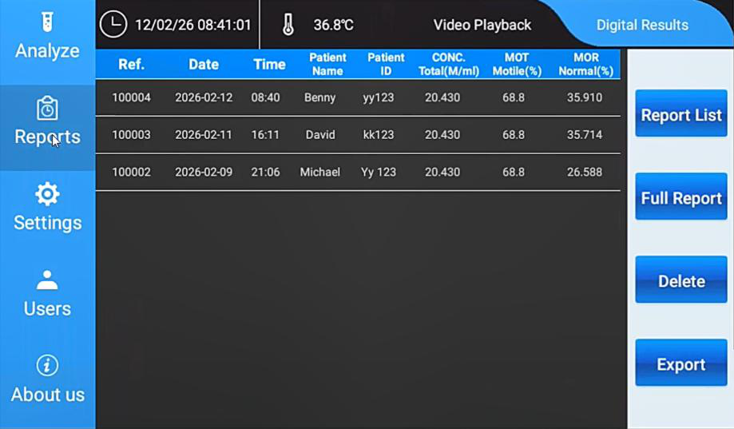

Figure 25. Reports Main Screen

4.2.3.1Open the Reports Function
1.Tap Reports on the left navigation bar.
2.The system enters the Reports function area.
3.Tap Report List if the report list is not already displayed.
4.Confirm that Digital Results is selected at the top of the screen.
The main area displays all saved test results in a list.
4.2.3.2Report List
The Report List displays saved test records. Each row represents one completed test.
Typical columns include:
•Ref.
•Date
•Time
•Patient Name
•Patient ID
•CONC. Total (M/ml)
•MOT Motile (%)
•MOR Normal (%)
To select a report, tap one row in the list. The selected row is used for Full Report, Delete,
and Video Playback operations.
4.2.3.3Open a Full Report
To open the full report of a selected result:
1.Enter Reports.
2.Tap Report List.

3.Select one report row from the list.
4.Tap Full Report on the right side.
The screen changes from the report list to the selected report’s digital result view.
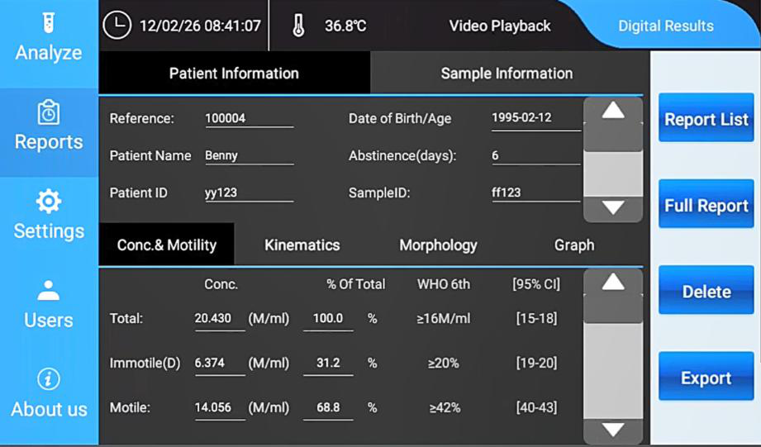
Figure 26. Full Report - Digital Results

4.2.3.4Review Digital Result Data
In the full report view, the patient and sample information is shown in the upper part of
the screen. The digital result data is shown in the lower part of the screen.
The operator can switch between the following result tabs:
•Conc. & Motility
•Kinematics
•Morphology
•Graph
Tap each tab to review the corresponding result category for the selected test.

4.1 Conc. & Motility
The Conc. & Motility tab displays concentration and motility results, such as total concentration, immotile sperm, motile sperm, percentage of total, WHO 6th Edition reference information, and confidence interval information where available.
4.2 Kinematics
The Kinematics tab displays sperm motion parameters calculated by the system. These values describe the movement characteristics of the analyzed sperm cells.
4.3 Morphology
The Morphology tab displays morphology-related analysis results for the selected test.
4.4 Graph
The Graph tab displays graphical summaries of the selected result, such as motility and morphology charts.
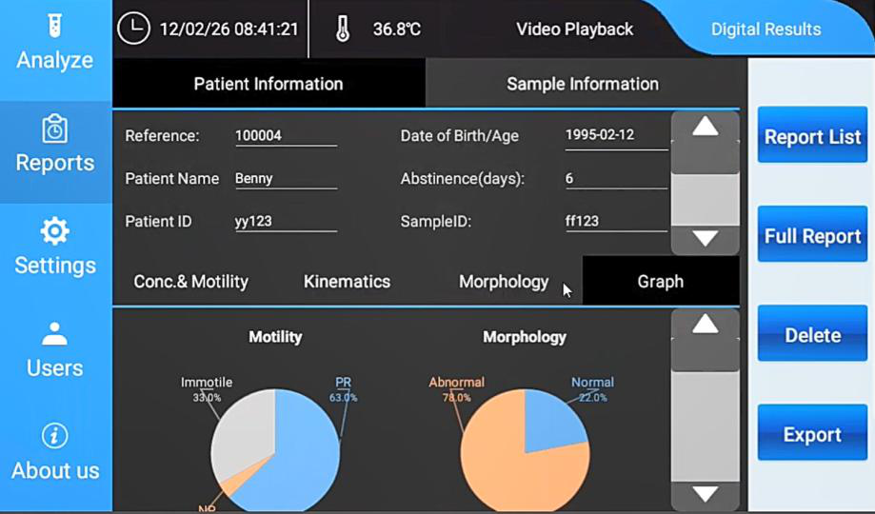

Figure 27. Full Report - Graph tab

4.2.3.5Video Playback
The operator can review the recorded microscopic video for a selected test.
To open video playback:
1.Open Reports.
2.Select a report from the report list, or open the report in Full Report view. 3.Tap Video Playback at the top of the screen.
The screen displays the microscopic video recorded during analysis.
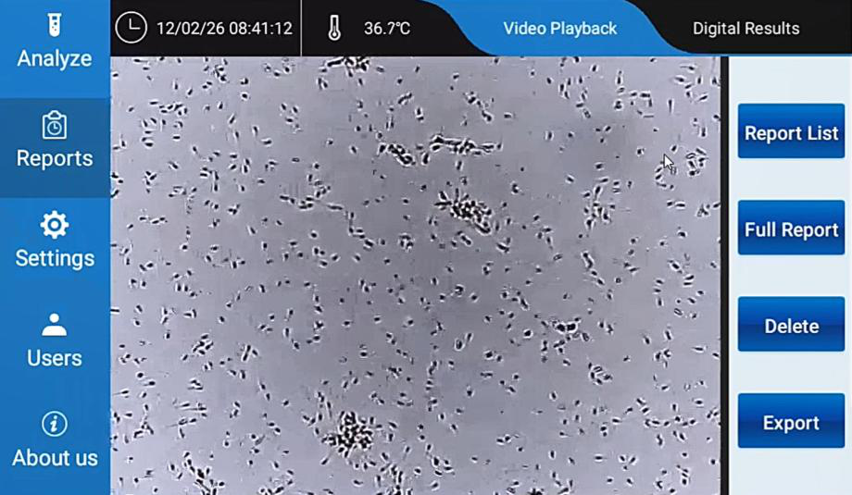
Figure 28. Video Playback

Use video playback to visually review the analyzed sample image. This function is helpful for record review, training, and troubleshooting.

Delete a Report
4.2.3.6Delete a Report
To delete a saved report:
1.Tap Reports on the left navigation bar.
2.Tap Report List.
3.Select the report row that should be deleted.
4.Tap Delete on the right side.
5.Confirm the deletion if a confirmation message appears.
Caution: Deleted reports may not be recoverable. Confirm that the correct report is selected before deleting it.
4.2.3.7Export Reports to USB Flash Disk
The Export function downloads saved report files to the USB flash disk supplied with the instrument.
To export reports: 1. Insert the USB flash disk supplied with the instrument into a USB port on the back of Nexus DX1.
2. Tap Reports on the left navigation bar.
3. Tap Export on the right side.
4. When the password prompt appears, enter: 000000 (default) 8.Confirm the export operation.
6. Wait until the system finishes downloading the report files to the USB flash disk. 10.Remove the USB flash disk only after the export is completed.
Note: Use the USB flash disk supplied with the instrument when exporting reports. Do not remove the USB flash disk during export.

4.2.3.8Recommended Operating Notes
•Use Report List to locate saved test results.
•Select the correct row before tapping Full Report, Delete, or Video Playback.
•Use Digital Results to review numerical result data.
•Use Video Playback to review the recorded microscopic video.
•Insert the supplied USB flash disk before using Export.
• Enter password 000000 (default) when prompted during export.
•Confirm that export is completed before removing the USB flash disk.
4.2.3.9Troubleshooting
Situation | Possible Cause | Recommended Action
The expected  report is not  visible in the list. | The result may be listed under its automatically assigned  reference number or another test time. | Check the Ref., Date, and Time columns.
Full Report does not open. | No report row is selected. | Select one report row, then tap Full Report again.
The wrong report was opened. | A different row was selected in the report list. | Return to Report List, select the correct row, and tap Full Report.
Video playback is not shown. | The operator is still in Digital Results view. | Tap Video Playback at the top of the screen.
Export does not start. | USB flash disk is not inserted or not recognized. | Insert the supplied USB flash disk into the USB port on the back of the instrument, then try again.
Password is  requested during export. | Export is password protected. | Enter 000000 (default).

4.2.4 Users
The Users function is used to manage the instrument password and edit local instrument
information. This information is stored and displayed on the instrument only.
In the current software version, the information edited in this section is used for local
reference and viewing only. It does not provide additional workflow, reporting, or remote
management functions.
4.2.4.1Open the Users Function
1.Tap Users on the left navigation bar.
2.The system enters the Password Management screen.
3.The right side of the screen displays brief notes for the current input area.
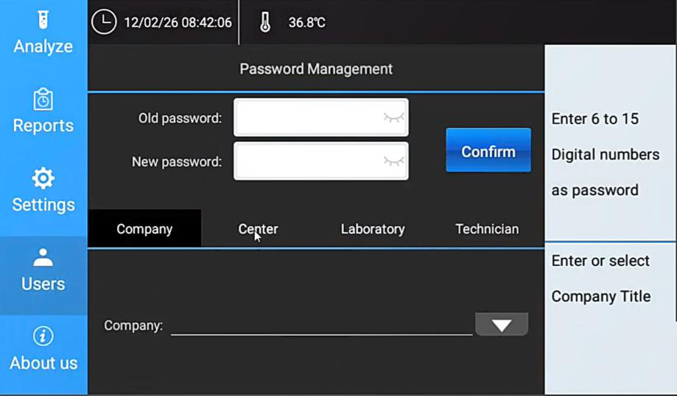
Figure 29. Users screen - Password Management

4.2.4.2Password Management
The instrument password can be changed in the Password Management area.
The default initial password is:
000000
To change the password:
1.Tap Users on the left navigation bar.
2.In the Old password field, enter the current password.
–For a new instrument or a password that has not been changed, enter 000000.
3.In the New password field, enter the new password.
4.Tap Confirm.
5.The system saves the new password.
The password must use digital numbers. The note on the right side of the screen indicates that the password should contain 6 to 15 digits.
Caution: Keep the new password in a safe place. If the password is changed and then lost, password recovery is not available from this function.
4.2.4.3Local Information
The lower part of the Users screen allows the operator to edit four categories of local information:
•Company
•Center
•Laboratory
•Technician
Tap the corresponding tab to enter or select information.
This information is used only for local instrument information storage and viewing. It currently has no additional function.
4.2.4.4Edit Company Information
1.Tap Users.
2.Tap Company.
3.Enter or select the company title.

4.Confirm or save the information according to the screen prompt.
The right-side note area displays brief guidance, such as:
“Enter or select Company Title”
4.2.4.5Edit Center, Laboratory, and Technician
To edit other local information:
1.Tap Users.
2.Tap Center, Laboratory, or Technician.
3.Enter or select the required information.
4.Confirm or save the information according to the screen prompt.
The entered information is stored locally on the instrument.
4.2.4.6Recommended Operating Notes
•The initial password is 000000.
•Change the password only when required by the laboratory or distributor.
•Record the new password and keep it secure.
•Use a 6 to 15 digit numeric password.
•Local Company, Center, Laboratory, and Technician information is for instrument
display and viewing only.
4.2.4.7Troubleshooting
Situation | Possible Cause | Recommended Action
The password cannot be changed. | The old password may be incorrect. | Enter the current password again. If the password has never been changed,  enter 000000 as the old password.
The new password is not accepted. | The password format may be incorrect. | Use a numeric password with 6 to 15 digits.
The operator forgot the changed  password. | The password was changed and not recorded. | Contact the distributor or service provider. Password recovery is not available from this function.
Local information has no visible effect on | The information is for local storage and | Use this section only for local  instrument information management.

Situation | Possible Cause | Recommended Action
analysis. | viewing only.

Warning: Never clean lenses with alcohol, ordinary tissues, cleaning paper, toilet paper, cotton wool or hand towels, which will scratch the lens surface.
Warning: Do not use volatile materials such as benzene or thinner for cleaning. Use of such materials will discolor and/or damage key device surfaces. Do not use organic solvents. Also, please do not scrape strongly during cleaning.
Warning: You should be extremely careful not to damage the objectives as they are a very sensitive part of the system.
Warning: Please don’t let any solvent, lip and erosive material touch the equipment.

Warning: Alternating current power must be well earthed.

Alternating current power must be stable. It is prohibited to use power source

with high-power equipment together, and it’s better to equip with voltage-regulated power supply.
If there is smoke, abnormal smell or strange sound of equipment, cut off the

power at once, and contact with the distributor.

When power line is inserted or pulled out, you must hold plug itself, not the

power line.
Warning: Avoid cleaning with hard or sharp objects.
Warning: Do not wash the device with water.
Warning: Ensure that the power switch is in the off (“0”) position before connecting the equipment to the power source.



Appendix A. Additional Operating Guidance
This appendix supplements the original manual structure with additional common user-manual content for safe operation, routine maintenance, troubleshooting, and operator responsibility. It does not replace local laboratory standard operating procedures.

A.1 Warning, Caution, and Note Definitions
- Warning: Indicates a risk that may cause personal injury, infection risk, electrical hazard, or serious instrument damage.
- Caution: Indicates a condition that may affect instrument performance, test reliability, or data integrity.
- Note: Provides useful operating information or recommended practice.

A.2 Operator Responsibilities
- Operate Nexus DX1 only after appropriate training.
- Handle human semen samples as potentially infectious biological material.
- Use approved consumables and follow laboratory sample preparation procedures.
- Confirm date, time, temperature setting, calibration status, and quality control requirements before routine use.
- Do not use instrument output as the sole basis for clinical decision-making. Final interpretation must be performed by qualified professionals.
- Maintain traceability of sample identification, operator, result records, exported reports, and deleted reports according to laboratory policy.

A.3 Routine Maintenance Recommendations
- Before use: Check the power cable, adapter, touchscreen, sample loading area, and general cleanliness.
- Before analysis: Confirm that the heating stage has reached the configured temperature.
- After sample handling: Remove used consumables and dispose of them as biological or medical waste.
- As needed: Wipe external surfaces with a soft lint-free cloth. Do not spray liquid directly onto the instrument.
- As required by the laboratory: Perform QC or calibration checks according to the approved procedure.
- When exporting reports: Use the USB flash disk supplied with the instrument and do not remove it during export.

A.4 General Troubleshooting
Situation | Possible Cause | Recommended Action
Instrument does not power on. | Power adapter not connected, power switch off, or outlet unavailable. | Check the outlet, adapter, cable, and rear power switch.
Heating stage does not reach target temperature. | Warm-up time, setting, environment, or system issue. | Confirm the setting and allow warm-up time. Contact service if unresolved.
USB flash disk is not recognized. | USB disk not inserted correctly or unsupported device. | Use the supplied USB flash disk and insert it into a rear USB port.
Report cannot be found. | The record may be stored under the automatically assigned reference number. | Search by Ref., date, time, patient name, or sample ID.
Abnormal smell, smoke, or unusual sound occurs. | Possible electrical or internal fault. | Turn off power immediately, disconnect the adapter, and contact service.

A.5 Information to Confirm Before Final Release
- Final regulatory intended-use statement.
- Final product label power rating and power adapter specification.
- Final user-adjustable temperature range.
- Final packing list and accessory names.
- Whether LIS, HL7, RJ45, or PC workstation functions are enabled in the released product configuration.
- Final warranty, service, and distributor contact wording.

